User Authentication

Users  - Primary  - Kolavo visitors  - Secondary  - Kolavo users | Phase 1
Intended Outcome
- To persuade visitors that signing up and logging into Kolavo is worth it
- To ease Kolavo visitors to sign up and Kolavo users to log in
Links
- …
- …
- …
- …
- …

Introduction
As a newly released app, people may not know how Kolavo will make their community lives better which may lead to resistance to creating an account. To flip people’s perspectives, Kolavo needs to persuade them by giving proof of being a distinct community app and ease them to be users when their interest has increased. This can be done by showing visitors the good looking for a community page including clear community profile and engaging community member distributions where both can be the reason official community organizers want to create their own community pages and community members want to join their communities.

Product Requirement
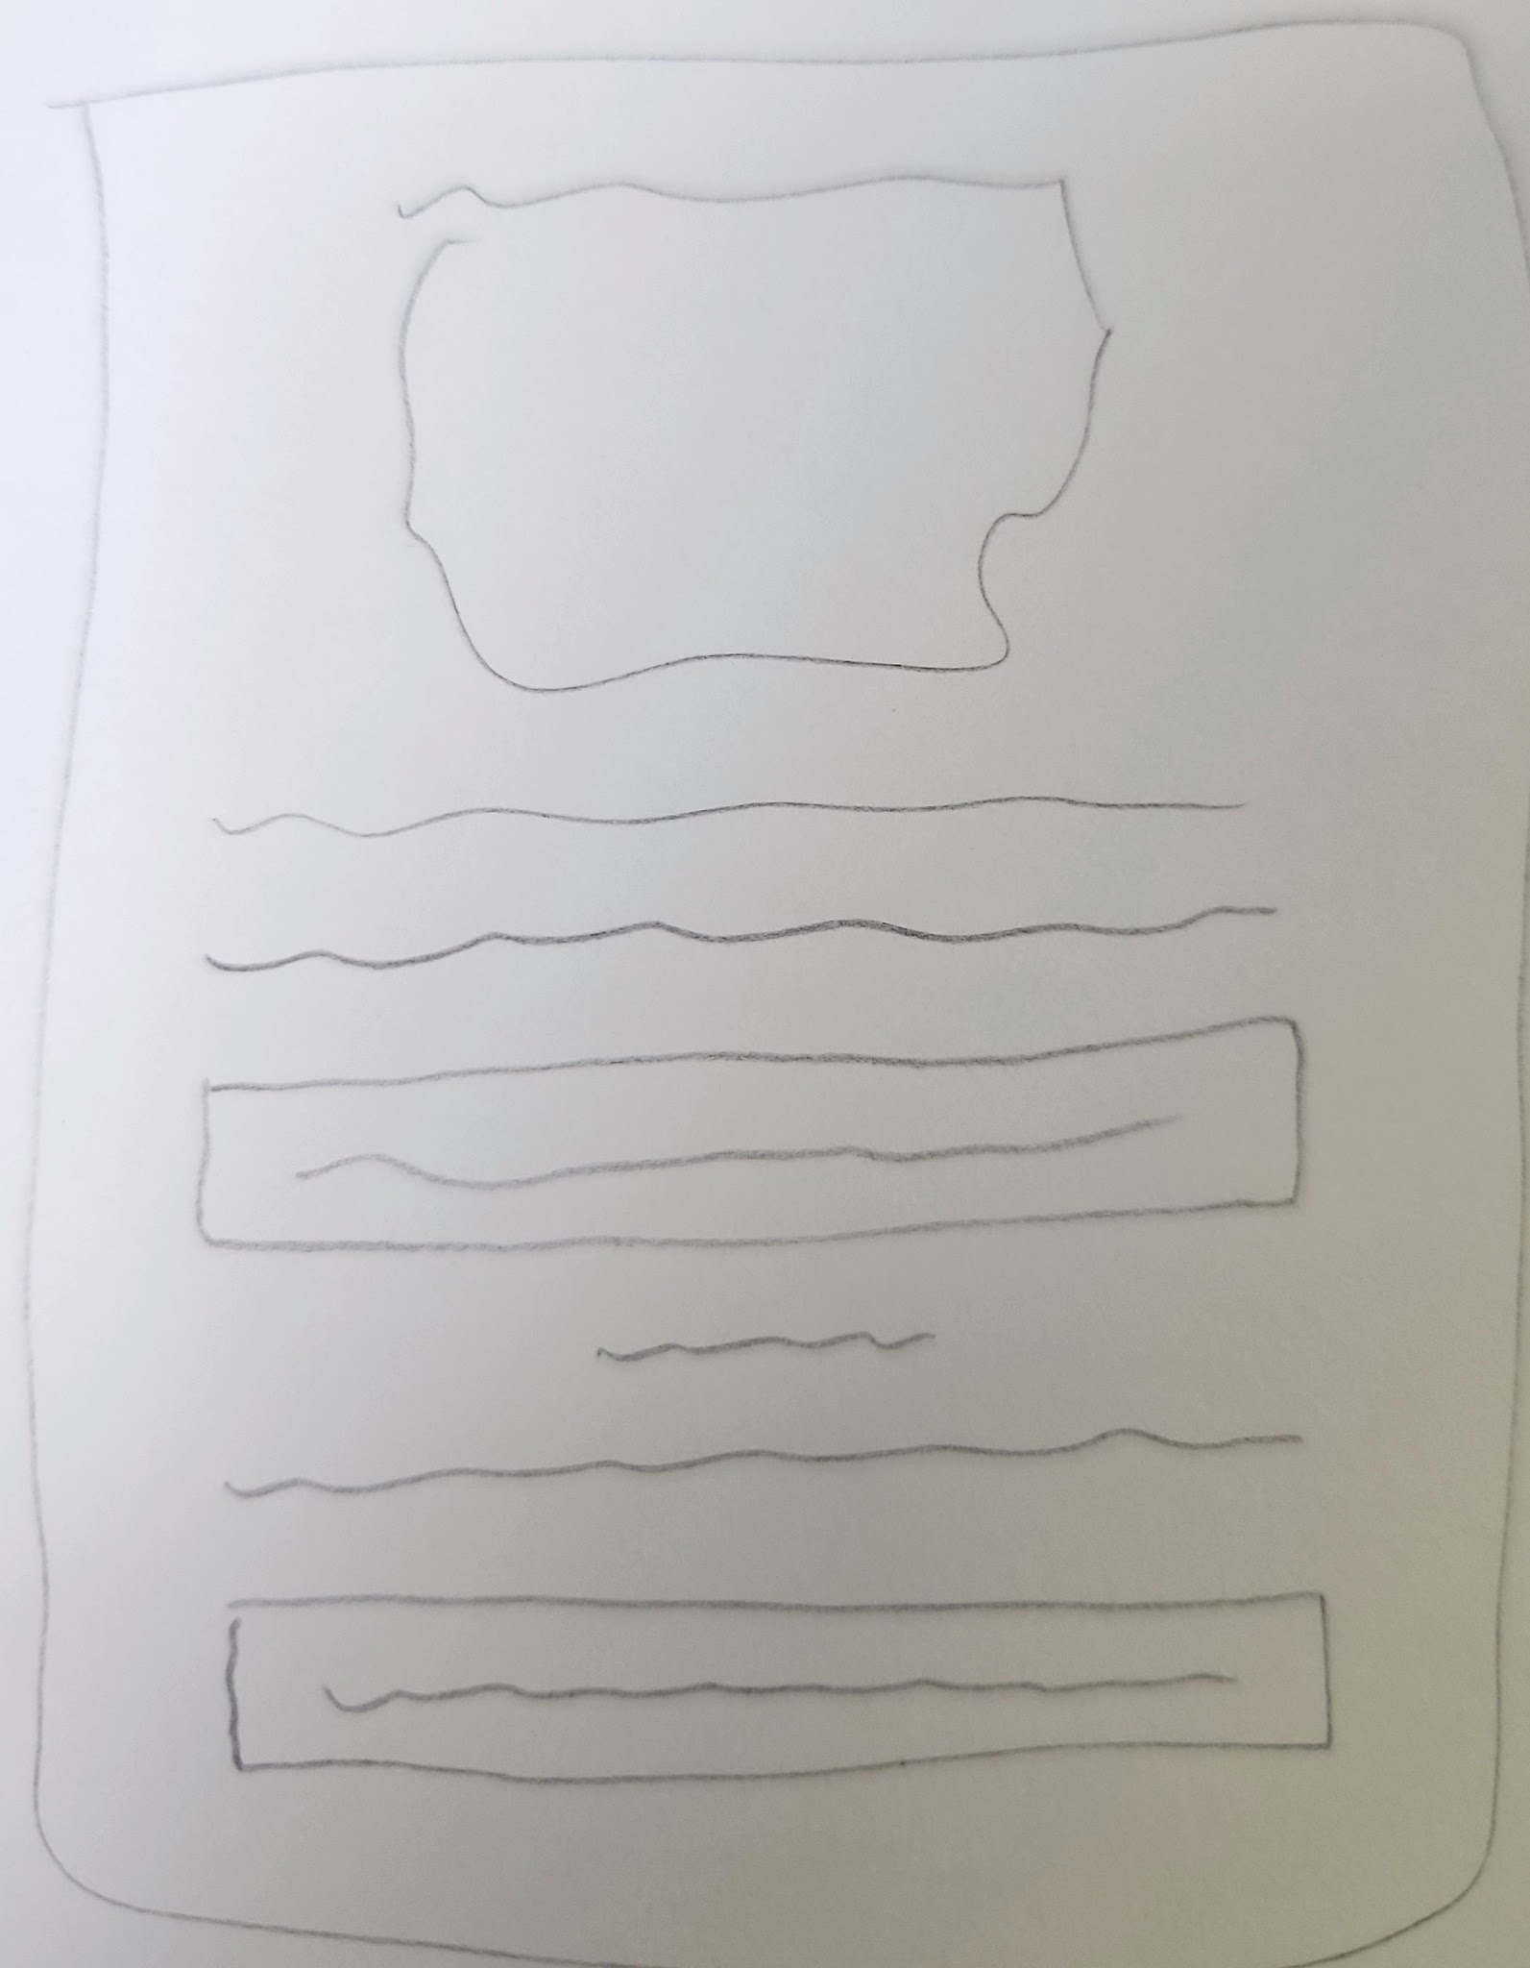
Authentication Modal

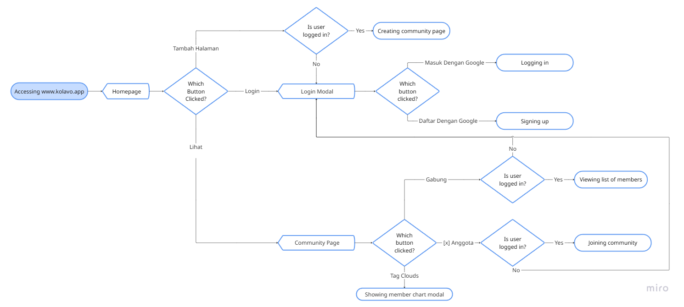
Sign Up and Login Flow

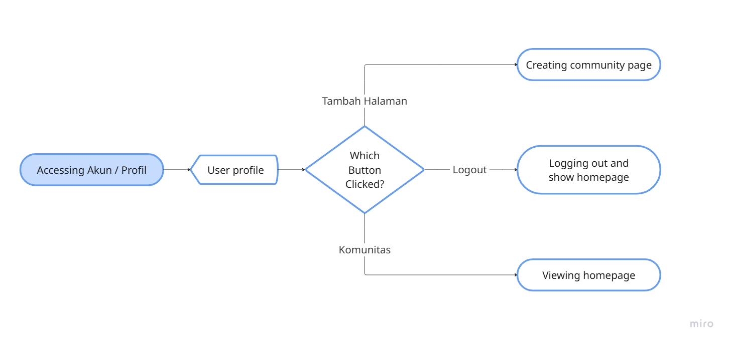
Logout Flow

No | User story | Scope | Acceptance Criteria
1 | As visitors who officially organize a community and have seen how good community pages look, I want to register, so that I can create and publish my own community page. | Login | - Triggering login is not only at the login button, but also at the button where only registered and logged in users can access which are:  - Create community page (admin)  - Join as member (member)  - Seeing list of members  - Login form shown at a modal not a page.  - Login method is Google SSO
2 | As visitors who are officially part of a community and have seen how registered members describe member distribution, I want to register, so that I can join my communities in Kolavo. | Login
3 | As visitors who don’t have an account, I want to register easily, so my interest in registering remains. | Sign up | - In the login modal, ease visitors to find the sign up button.  - The sign up method is Google SSO.
4 | As visitors who don’t want to keep login, I want to see the logout button, so I can log out. | Logout | - Logout button at the user profile  - System shows Homepage as user logout

Design Requirement

Login and Sign Up Modal
Design Intent | To keep user’s interest while having authentication requirement
Content / Copy | - Heading: Masuk Dulu, Yuk!  - Body: Biar bisa pakai Kolavo untuk kenal dengan anggota komunitasmu.  - Login Button: Masuk dengan Google  - Body:  Atau  Daftar jika belum punya akun  - Sign up button: Daftar dengan Google
Visual Requirement
Interaction Behavior | - Clicking login button proceeds to login  - Clicking sign up button proceeds to signup  - Clicking outside modal closes the modal
Acceptance Criteria

Login and Sign Up Modal
Design Intent | To allow user log out from the app
Content / Copy | - Logout icon
Visual Requirement
Interaction Behavior | - Clicking logout button proceeds to logout and redirects to homepage
Acceptance Criteria

Engineering Requirement

Questions

